**Buggy Cars Rating Bug Report**  
  
1. **Title**: Broken home page navigation link.

**Severity**: High

**Description**: The home page navigation link on the website appears to be broken. When the user clicks on the "Buggy Rating" button on the top left corner of the screen from the popular make page, the page fails to load. This issue is consistent across multiple browsers and devices.

**Steps to reproduce**:

1. Launch the Buggy Cars Rating website.
2. Navigate to Popular Make screen by clicking popular make image.
3. Click on the "Buggy Rating" button on the top left corner of the screen to go back to homepage.

**Expected Result**: Clicking on the " Buggy Rating " button should redirect the user to the home page of the Buggy Car Rating website.

**Actual Result**: The page fails to load and displays.

**Impact**: This issue affects the usability of the website, as users are unable to access the home page through the navigation bar. It may result in a loss of website traffic and potential customers.

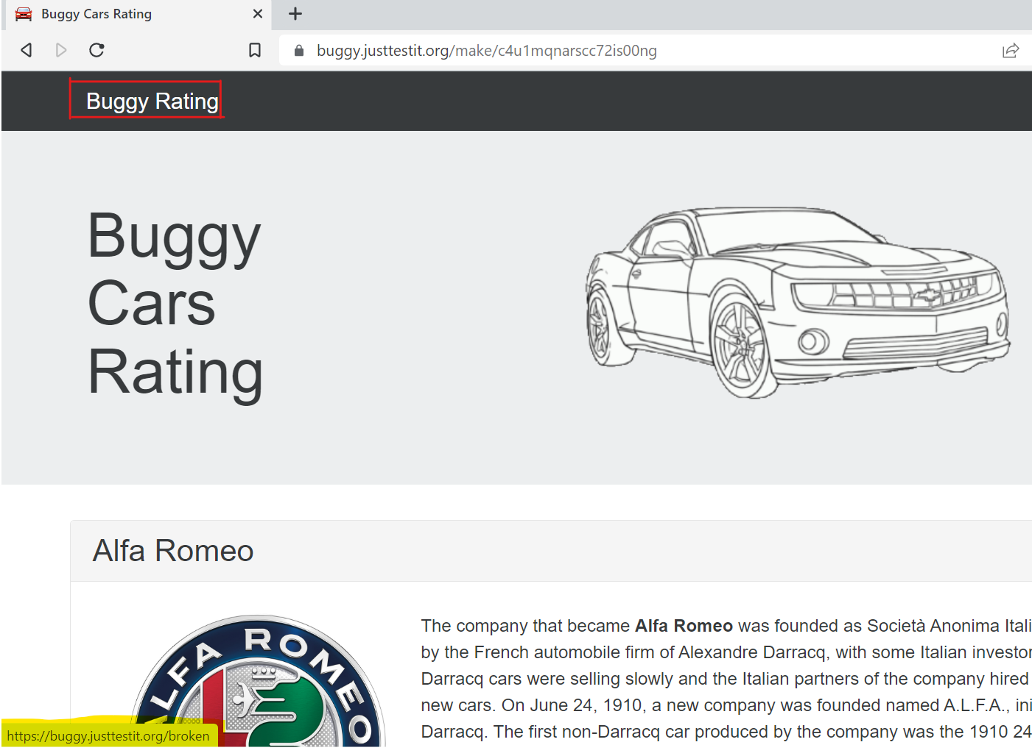

2. **Title**: Incorrect Rank column sorting

**Severity**: High

**Description**: When using the sorting function on the website to sort through car listings, it was observed that the entries were not being arranged correctly. Despite selecting rank column on the table, the results did not display in an orderly fashion. As a result, the user was unable to easily browse through the listings and compare options.

**Steps to reproduce**:

1. Launch the Buggy Cars Rating website.
2. Navigate to Overall Rating screen by clicking overall rating image.
3. Click on the Rank column.

**Expected Result**: After clicking rank column, the entries should be arranged in a logical and organized manner, allowing the user to easily browse through and compare listings.

**Actual Result**: Despite selecting sorting criteria, the entries are not arranged properly, causing difficulty in browsing through the listings.

**Impact**: This bug impedes the user's ability to efficiently browse through car listings based on ranks, which is a key functionality of the website.

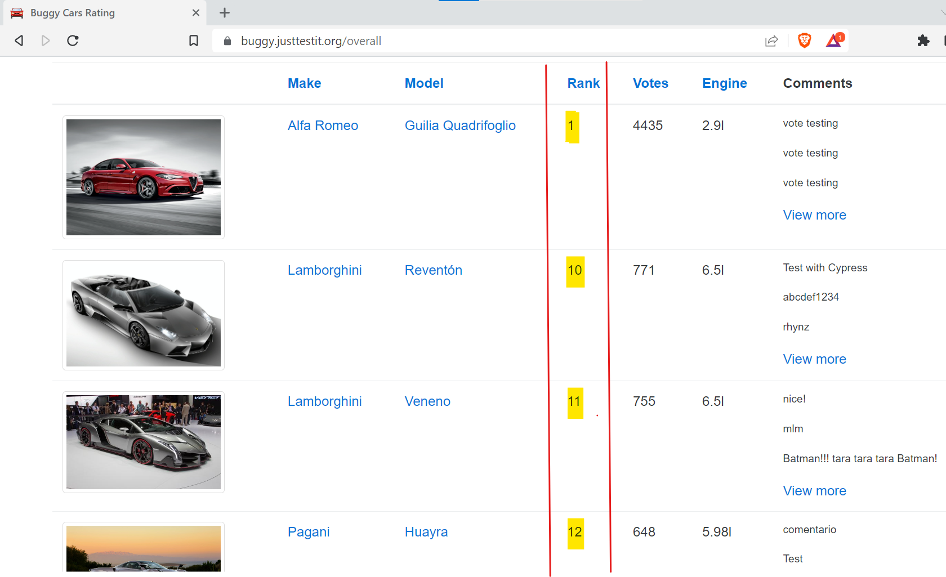

3. **Title**: Traversing through overall rating page gives empty response.

**Severity**: High

**Description**: When attempting to navigate to different pages using the pagination buttons at the bottom of the page, the website fails to display data. Instead, it displays a blank page.

**Steps to reproduce**:

1. Launch the Buggy Cars Rating website.
2. Navigate to Overall Rating screen by clicking overall rating image.
3. Scroll down to the bottom of the page to locate the pagination buttons.
4. Click on any page number to load the corresponding page.

**Expected Result**: After the last page (5 in our case) the forward page button should be disabled if there is no further data.

**Actual Result**: The website displays a blank page after the last page with data.

**Impact**: This bug impedes the user's ability to efficiently browse through car listings, which is a key functionality of the website.

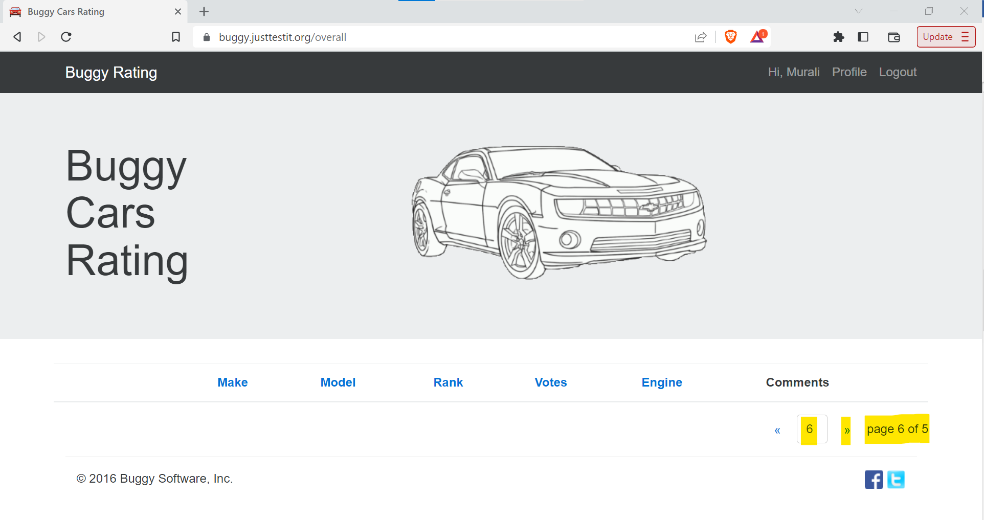

4. **Title**: Broken image on the overall rating page table

**Severity**: High

**Description**: On the overall rating page, the images on the table is broken. The image is not displayed properly, and instead, a broken image icon is shown.

**Steps to reproduce**:

1. Launch the Buggy Cars Rating website.
2. Navigate to Overall Rating screen by clicking overall rating image.
3. Scroll down to the table of available list of cars.
4. Observe the image for the car model “Lancia Ypsilon”.

**Expected Result**: The image for the car model “Lancia Ypsilon” should be displayed properly, without any issues.

**Actual Result**: The image for the car model “Lancia Ypsilon” is not displayed properly, and a broken image icon is shown instead.

**Impact**: This bug impedes the user's ability to efficiently browse through car listings, which is a key functionality of the website.

5. **Title**: Incorrect Votes column sorting

**Severity**: High

**Description**: When using the sorting function on the website to sort through car listings, it was observed that the entries were not being arranged correctly. Despite selecting votes column on the table, the results did not display in an orderly fashion. As a result, the user was unable to easily browse through the listings and compare options.

**Steps to reproduce**:

1. Launch the Buggy Cars Rating website.
2. Navigate to Popular Make screen by clicking overall rating image.
3. Click on the Votes column.

**Expected Result**: After clicking votes column, the entries should be arranged in a logical and organized manner, allowing the user to easily browse through and compare listings.

**Actual Result**: Despite selecting sorting criteria, the entries are not arranged properly, causing difficulty in browsing through the listings.

**Impact**: This bug impedes the user's ability to efficiently browse through car listings based on votes, which is a key functionality of the website.

